A description of the implementation of the methods, including information on how they are trained and tuned, and the specific parameters used.
数据预处理：
在数据预处理过程中，首先查看到数据拥有10个分类，他们的图片数据被存储在10个不同的文件夹中，首先将图片的路径地址，图片所属于的类型存入到同一个Dataframe中。然后对图片的labels进行encoding。将数据进行打乱。对数据集按照百分之70为训练数据集，百分之20为验证数据集，百分之10为测试数据集对数据进行切分。
将数据进行封装，利用torch中的Dataset对数据和label进行封装，并对图片进行变化。图片按照（180,180）进行转换。dataset分账的数据将返回tensor类型，因为DataLoader函数只接受tensor类型的输入。然后利用DataLoader规定数据集的batch size。这时就已经准备好了可以利用模型进行训练的数据。
In the data preprocessing process, the data has 10 categories and the image data is stored in 10 different folders, firstly, the path address of the image, the type to which the image belongs is stored in the same dataframe. Then the images are encoded in the labels and the data are disrupted. The dataset is sliced according to 70% as training dataset, 20% as validation dataset and 10% as test dataset. Wrap the data, using Dataset in torch to wrap the data and labels, and vary the images. The images are transformed according to (180,180). dataset binning data will return tensor type because the DataLoader function only accepts input of tensor type. The DataLoader is then used to specify the batch size of the dataset. at this point the data is ready for training with the model.

模型构建
全连接神经网络：全连接神经网络的输入输出是固定的，输入为经过变换后的图片的180*180*4,4为通道数。输出则为图片的所有种类10种。全连接神经网络的架构是链式结构，每一层都是前一层的函数。每一层又有多个节点组成（课件feedforward单神经元模型图）该模型的激活函数分别使用了sigmoid和relu函数在相同神经元数量下进行了训练比较。评估将采用准确率。
神经元数量在第一层隐藏层为512，第二层隐藏层的神经元数量为256。神经元的数量尽量以2^n来设定。
The input and output of the fully connected neural network are fixed values, the input is 180*180*4, 4 is the number of channels of the transformed image. The output is all kinds of 10 kinds of images. The architecture of the fully connected neural network is a chain structure, where each layer is a function of the previous layer. Each layer is in turn composed of multiple nodes
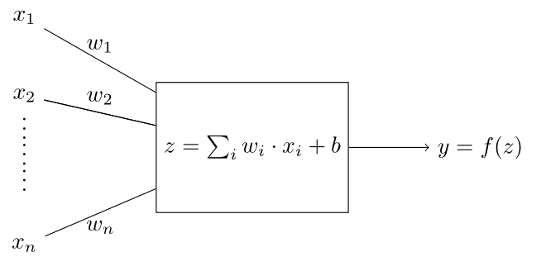
The activation functions of this model are compared using sigmoid and relu functions trained at the same number of neurons, respectively. Accuracy will be used for evaluation. The number of neurons is 512 in the first hidden layer and 256 in the second hidden layer. the number of neurons is set at $2^n$ as much as possible.

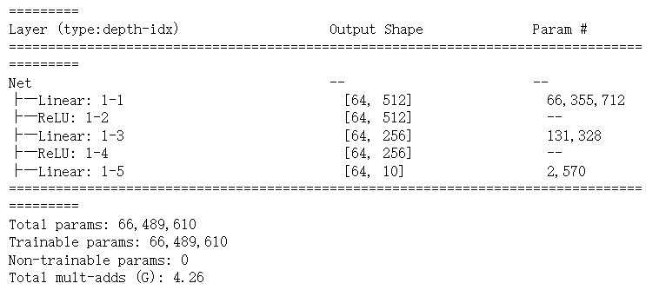
两层的激活函数都为Relu函数，ReLU函数的特点是当输入x大于0时，输出等于输入x，当输入x小于等于0时，输出为0。因此，ReLU函数的图像是一个从原点开始的斜率为1的直线和一条水平线组成的函数。Sigmoid函数的特点是在输入x很大或很小的时候，输出值接近0或1，而在输入接近0的时候，输出值约为0.5。因此，Sigmoid函数的图像是一个在原点处取最大值为1的S形曲线。
The activation function of both layers is the Relu function. the ReLU function is characterized by an output equal to input x when input x is greater than 0 and an output of 0 when input x is less than or equal to 0. Therefore, the image of the ReLU function is a function consisting of a straight line with slope 1 and a horizontal line from the origin. the Sigmoid function is characterized by an output value close to 0 or 1 when input x is large or small, and an output value about 0.5 when input is close to 0. Therefore, the image of the Sigmoid function is an S-shaped curve taking the maximum value of 1 at the origin. The image of the Sigmoid function is therefore an S-shaped curve that takes the maximum value of 1 at the origin.

根据表格中得到的实验数据，通过对模型的训练和评估，relu的准确率和损失的减小的效果比sigmoid激活函数要好很多。如下图。
According to the experimental data obtained from the table, by training and evaluating the model, the accuracy and loss reduction of relu is much better than the sigmoid activation function. The figure below.
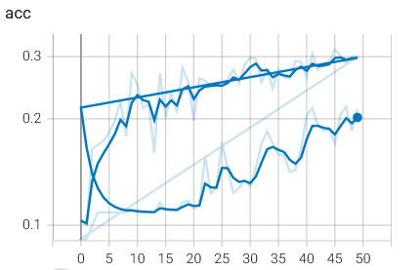

Model | Loss | Accuracy | Epoachs | Test
Fc_RELU | 2.0630 | 0.2989 | 50 | 0.2099
Fc_RELU | 1.9417 | 0.2131 | 100 | 0.2399
Fc_Sigmoid | 2.2987 | 0.3619 | 50 | 0.0299
Fc_Sigmoid | 2.2870 | 0.2017 | 100 | 0.2299
造成原因：sigmoid会导致梯度消失。神经网络在进行反向传播过程中，各参数层的梯度计算会涉及到激活函数导数的值。例如一个三层函数lesson13.3（梯度消失第一个公式）。当神经网络层数继续增加、激活函数的数量继续增加，第一层参数在计算梯度的过程中需要相乘的激活函数导函数个数也会随之增加，而后面几层参数的梯度计算中涉及到的激活函数导函数个数逐级递减。不同层参数的梯度在计算过程中都有很大的差异，并且这种差异是一种累乘效应，而这种累乘效应会导致线性层参数的一部分梯度过大而另一部分过小，从而影响模型平稳训练。当梯度通过多个sigmoid函数时，每个sigmoid函数的导数都小于1，这导致梯度值逐渐缩小，并最终消失为0。如表格所示，sigmoid函数在50轮和100轮的迭代后，损失几乎没有改变。
The sigmoid causes the gradient to vanish. Neural network in the process of back propagation, the gradient calculation of each parameter layer will involve the value of the derivative of the activation function. For example, a three-layer equation{ref: eq1}\hat{y}=F(F(X*w_1)*w_2)*w_3. As the number of layers of the neural network continues to increase and the number of activation functions continues to increase, the number of activation function derivatives that need to be multiplied in the process of calculating the gradient for the first layer of parameters increases, while the number of activation function derivatives involved in the gradient calculation for the subsequent layers of parameters decreases step by step. The gradients of the parameters in different layers vary greatly in the calculation process, and this difference is a kind of cumulative effect, and this cumulative effect will lead to a part of the gradient of the linear layer parameters is too large and another part is too small, thus affecting the smooth training of the model. When the gradient passes through multiple sigmoid functions, the derivative of each sigmoid function is less than 1, which causes the gradient value to gradually shrink and eventually disappear to 0. As shown in the table, the loss of the sigmoid function remains almost unchanged after 50 and 100 rounds of iterations.

卷积神经网络：卷积是对两个实变函数的一种数学运算。使用了两种神经元参数。第一种，如下图所示。
Convolution is a mathematical operation on two functions of real variables. Two types of neuron parameters are used. The first one, as shown in the figure{ref: cnn_1} below.
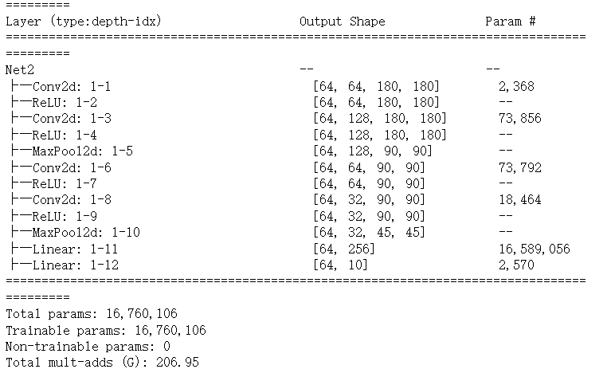
激活函数借鉴全连接网络构建的经验。激活函数均采用Relu函数。该网络由两个卷积层，一个最大池化层，两个卷积层，一个最大池化层，和两个全连接层组成。卷积层的kernel size为3x3，stride为1，padding为1.最大池化层的kernel size为3x3，stride为2，padding为1. CNN网络的输入通道将为图片的4个通道，输出为10给分类。最大池化层是可以摘选中的kernel区域中，选取最大的数值进行输出。最大池化层可以进行降维，减少计算量，加强图片的不变性。
第二种如下图所示，更改了最大池化层，和卷积的神经元数量。The second one is shown below, changing the maximum pooling layer, and the number of neurons for convolution.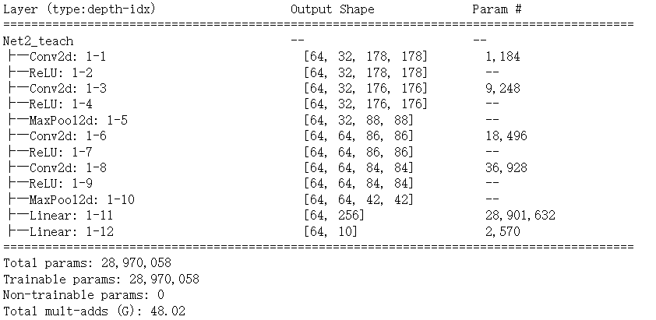
The activation functions draw on the experience of fully connected network construction. The Relu function is used for all activation functions. The network consists of two convolutional layers, a maximum pooling layer, two convolutional layers, a maximum pooling layer, and two fully connected layers. The convolutional layer has a kernel size of 3x3, stride of 1, and padding of 1. The maximum pooling layer has a kernel size of 3x3, stride of 2, and padding of 1. The input channels of the CNN network will be the four channels of the image, and the output will be 10 to the classification. The maximum pooling layer is able to pick the largest value in the kernel area for output. The maximum pooling layer can perform dimensionality reduction to reduce the computational effort and enhance the invariance of the image.

评估：
Model | Loss | Accuracy | Epoachs | Test
CNN_MODEL1 | 2.2720 | 0.2689 | 50 | 0.0599
CNN_MODEL1 | 2.0717 | 0.4363 | 100 | 0.4099
CNN_MODEL2 | 2.2650 | 0.3047 | 50 | 0.3299
CNN_MODEL2 | 1.9410 | 0.4105 | 100 | 0.3999
CNN_Norm | 1.2908 | 0.8226 | 50 | 0.6800
CNN_Norm | 0.8245 | 0.9942 | 100 | 0.6899
在第三个网络中，基于第一个CNN model模型增加了Batch Normalization，BN做的也就是对输入数据进行平移和放缩。只不过BN的平移和放缩分为两个阶段，第一个阶段是进行Z-Score处理，也就是将输入数据的均值平移至0点，并将输入数据的方差放缩至1；第二阶段则是在此基础上在对数据的均值进行参数平移（加上一个通过训练、也就是梯度下降算法算得的参数），并对其方差进行参数（另一个通过模型训练、也就是梯度下降算得的参数）放缩。
评估
在增加了Normalization层后，准确率有了一个明显的提升。提升的原因有以下几点：1. 目前网络结构简单，对于没有被Normalization的矩阵的处理并不理想。干扰过多。2.通过归一化，神经网络可以更快地收敛，因为每层的输入都被调整为具有类似的范围和分布。此外，Batch Normalization还有一定的正则化效果，因为它可以减少神经网络中的协变量偏移。
With the addition of Normalization layer, there is a significant improvement in the accuracy rate. The reasons for the improvement are the following: 1. The current network structure is simple and does not handle matrices that are not Normalized well. There is too much interference. 2. By normalization, the neural network can converge faster because the inputs of each layer are tuned to have a similar range and distribution. In addition, Batch Normalization has some regularization effect because it reduces the covariate bias in the neural network.
在第四个网络中，将优化器替换为RMSprop, SGD会根据当前样本的梯度更新参数模型。
RMSprop公式为\ref{RMSprop} $\eta$ 为学习率，$g_t$为梯度，$\epsilon$为超参数，为了不让分母为零。超参数$\alpha$用于对$G_{t-1}$和$g_t^{2}$做加权平均，用于梯度迭代的$\delta_t$被参数B控制。由于Glorot条件中所声明的：只有所有权重上的梯度值都比较接近时，模型才能具有较好的学习能力，整体损失才能够被优化到较好的局部最小值上，RMSprop增加了超参数用于更好的优化算法。通过使用自适应学习率，RMSprop能够更好地控制参数更新的幅度和方向，更稳定和可靠。
在处理非平稳目标函数时，RMSprop可以加速收敛速度，提高训练效果。
Replacing the optimizer with RMSprop, SGD will update the parametric model according to the gradient of the current sample.
The RMSprop formula is \ref{RMSprop} $\eta$ is the learning rate, $g_t$ is the gradient, and $\epsilon$ is the hyperparameter, in order to keep the denominator from being zero. The hyperparameter $\alpha$ is used to do a weighted average of $G_{t-1}$ and $g_t^{2}$, and $\delta_t$ for the gradient iterations is controlled by parameter B. Only when all the gradient values on all weights are relatively close, the model can have better learning ability and the overall loss can be optimized to a better local minimum, and RMSprop adds hyperparameters for a better optimization algorithm. By using adaptive learning rate, RMSprop can better control the magnitude and direction of parameter updates, and is more stable and reliable.
When dealing with non-smooth objective functions, RMSprop can accelerate the convergence speed and improve the training effect.

但是，在该模型和数据的应用显然并不适合使用RMSprop，在训练过程中，模型的损失出现了反复和增加。这证明，模型可能出现了向错误的方向的梯度下降。
准确率如下图所示，准确率最高的是Batch normalization 网络，准确率最低为使用了RMSprop网络。
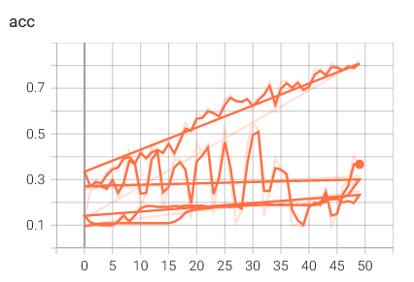
使用RMSprop的网络，在测试数据集上只获得了0.15在训练50轮时，0.22在训练100轮时。
The network using RMSprop only obtained 0.15 at 50 rounds of training and 0.22 at 100 rounds of training on the test dataset.

Future work：在未来的工作中可以增加网络的深度和层数，因为更深的模型在任务重泛化更好。（花书p174，Bengio引用）

• The performance of all the methods used.
• A discussion regarding the comparison of the results obtained by the methods used.

